Adverbs (They modify adjectives or adverbs) | Adjectives (They modify nouns and pronouns)
Extremely | Happy
Quite | Sad
Really | Big
Fairly | Small
Rather | Bright
Very | Dark
Too | Beautiful
So | Ugly
Incredibly | Warm
Absolutely | Sandy
Surprisingly | Fast
Particularly | Slow
Totally | Smooth
Truly | Rough
Remarkably | Black
Moderately | Pink
Slightly | Tall
Hugely | Short
Especially | Cheerful
Completely | Gloomy
Football
Describe the pictures:
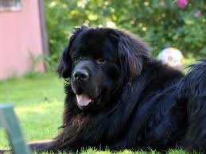 < Look at the animal in the photo. It’s a dog.
Dog
Garden
I use it’s because I already told you to look at the photo. you already know that it’s describing the animal.
Subject or Pronoun | + | Verb | + | Article | + | Adjective | + | Adjective | + | Noun
It | + | is | + | a | + | big | + | black | + | dog

Subject or Pronoun or Article | + | Noun | + | Verb | + | Adverb | + | Adjective
The | + | dog | + | is | + | very | + | big
Notice: The noun can be placed in two positions. The last word receives the emphasis.
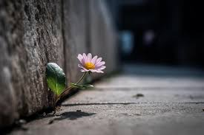< This is a flower
flower
bricks
leaf
I use ‘this’ because the text is speaking. The text is describing the picture that is next to it.

Subject or Pronoun | + | Verb | + | Article | + | Adjective | + | Adjective | + | Noun
The flower | + |  | + |  | + |  | + |  | +

Subject or Pronoun or Article | + | Noun | + | Verb | + | Adverb | + | Adjective
The | + |  | + |  | + |  | +
Notice: The noun can be placed in two positions. The last word receives the emphasis.
bed
teddy bear
boy
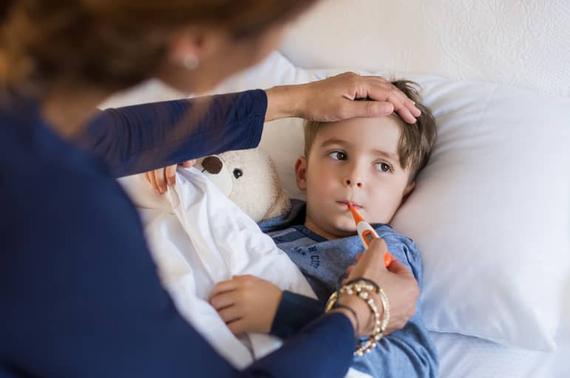< This is a boy. His name is Mark.
Mom?
bracelets
thermometer
I use ‘this’ because the text is speaking. The text is describing the picture that is next to it.
Also, we don’t use ‘it’ for describing people.
Subject or Pronoun | + | Verb | + | Article | + | Adjective | + | Adjective | + | Noun
Mark | + |  | + |  | + |  | + |  | +

Subject or Pronoun or Article | + | Verb | + | Adverb | + | Adjective
Mark | + |  | + |  | +

Notice: The noun can be placed in two positions. The last word receives the emphasis.
Flower Bed
Garden
House
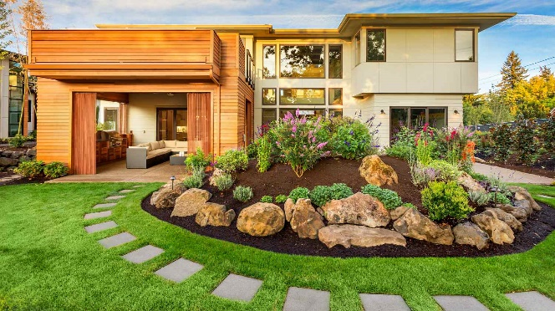
Flowers
Path
Subject or Pronoun | + |  | + | Article | + | Adjective | + | Adjective | + | Noun
 | + |  | + |  | + |  | + |  | +

Subject or Pronoun or Article | + |  | + | Adverb | + | Adjective
 | + |  | + |  | +
Sand
Rocks
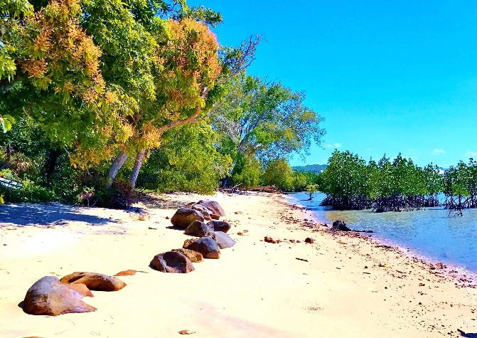
Beach
Subject or Pronoun | + | Verb | + |  | + | Adjective | + | Adjective | + | Noun
 | + |  | + |  | + |  | + |  | +

Subject or Pronoun or Article | + | Verb | + | Adverb | +
 | + |  | + |  | +

